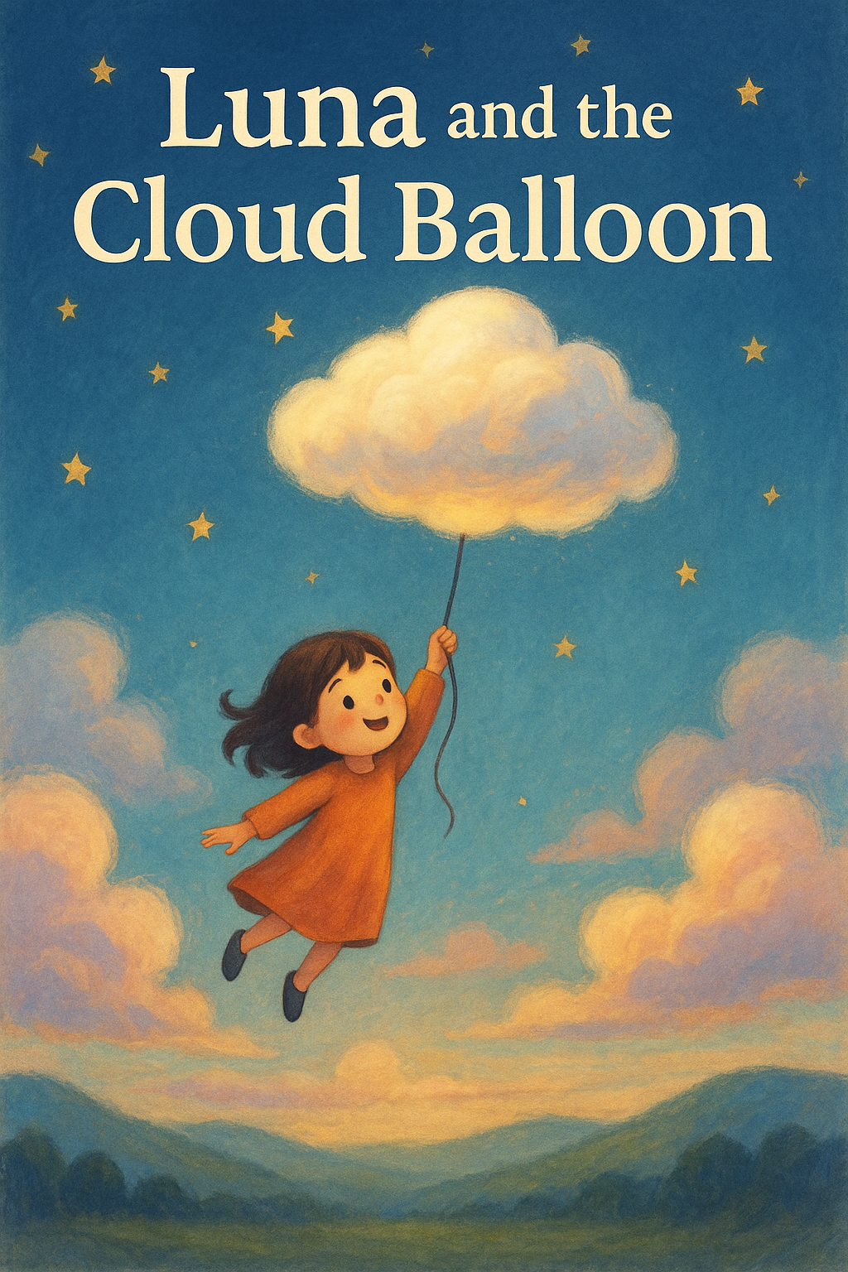

Luna was a little girl who lived   
in a quiet village, nestled between green hills and clear skies.   
Every morning, she gazed up at the clouds and imagined them floating away like balloons.

One breezy afternoon, Luna spotted a fluffy white cloud shaped just like a giant balloon. "I wish I could fly with you," she whispered. Suddenly, the cloud dipped low and hovered above her garden.

Without thinking twice, Luna climbed up a ladder leaning against a tree and reached out. The moment her fingers touched the cloud, it lifted her gently into the sky!

Up and up they soared, passing birds, waving treetops. Luna giggled as the wind tickled her cheeks.

The cloud balloon took her to a secret place above the clouds,  
a floating island made of mist and light! There were dancing cloud animals and a tiny sun that shone just for them.

But as evening painted the sky orange and pink, Luna felt a little tug in her heart. “I think it’s time to go home,” she told the cloud.

The cloud balloon gently drifted down, landing Luna safely in her garden. She waved goodbye as it floated into the sunset, forever believing that some clouds are more than just clouds.

The End.